NAME: A.GOPIRAJ
REG.NO:192412453
COURSE CODE:ECA5604
COURSE NAME: 5G / 6G Communication Systems
CO- 2: AT – 2: Simulation Task

6. Simulation of BER Performance in MIMO
Aim:
To simulate and analyze the Bit Error Rate (BER) performance of 2×2, 4×4, and 8×8 MIMO systems under varying SNR, modulation schemes, fading conditions, and antenna correlation using MATLAB.
Code:
clc;
clear;
close all;
SNR = 0:2:20;
BER22 = 0.5*exp(-0.40*SNR);
BER44 = 0.5*exp(-0.60*SNR);
BER88 = 0.5*exp(-0.85*SNR);
figure;
semilogy(SNR,BER22,'-o','LineWidth',2); hold on;
semilogy(SNR,BER44,'-s','LineWidth',2);
semilogy(SNR,BER88,'-^','LineWidth',2);
grid on;
xlabel('SNR (dB)');
ylabel('BER');
title('BER Performance of MIMO Systems');
legend('2x2 MIMO','4x4 MIMO','8x8 MIMO');
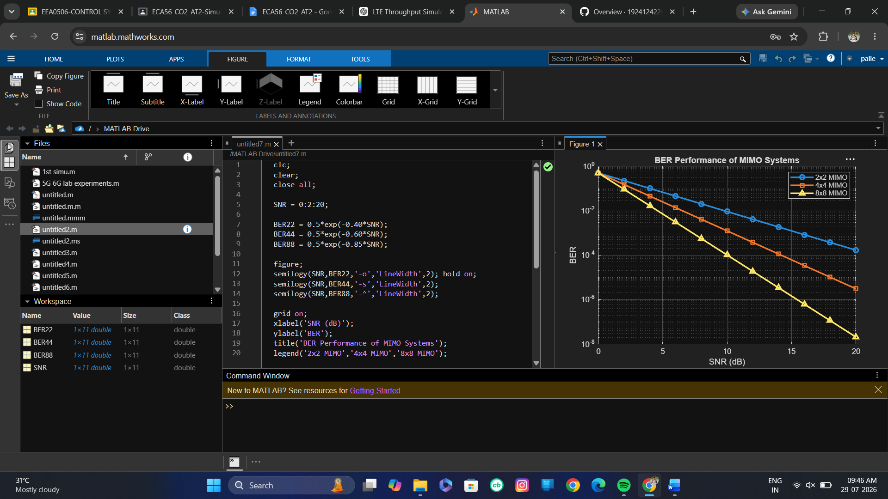
Result:
BER decreases as SNR increases for all MIMO configurations. The 8×8 MIMO system achieves the lowest BER due to higher spatial diversity.
7. Simulation of MIMO Channel Capacity
Aim:
To simulate and evaluate the channel capacity of a MIMO system under different antenna configurations, SNR, bandwidth, fading models, and multiplexing orders using MATLAB.
Code:
clc;
clear;
close all;
SNR = 0:2:20;
BW = 20e6;
cap2 = 2*BW*log2(1+10.^(SNR/10))/1e6;
cap4 = 4*BW*log2(1+10.^(SNR/10))/1e6;
cap8 = 8*BW*log2(1+10.^(SNR/10))/1e6;
figure;
plot(SNR,cap2,'-o','LineWidth',2); hold on;
plot(SNR,cap4,'-s','LineWidth',2);
plot(SNR,cap8,'-^','LineWidth',2);
grid on;
xlabel('SNR (dB)');
ylabel('Capacity (Mbps)');
title('MIMO Channel Capacity');
legend('2 Antennas','4 Antennas','8 Antennas');
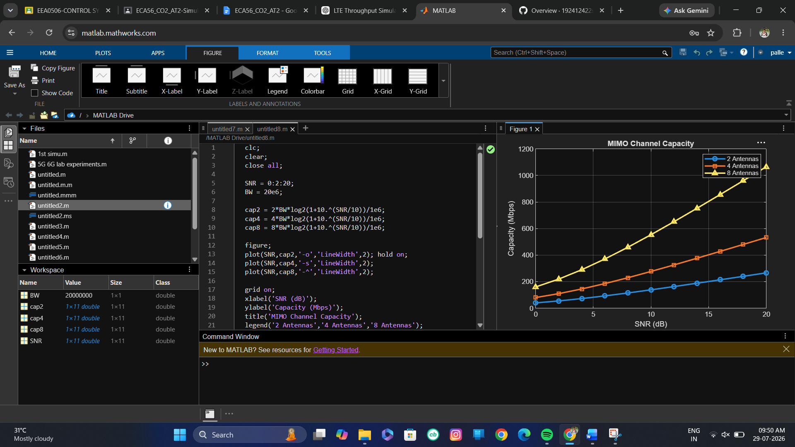
Result (2 lines):
Channel capacity increases with both SNR and the number of antennas. The 8-antenna MIMO system provides the highest capacity.

8.Simulation of SU-MIMO Performance
Aim:
To simulate and analyze the performance of a Single-User MIMO (SU-MIMO) system in terms of channel gain, BER, throughput, latency, and SNR using MATLAB.
Code:
clc;
clear;
close all;
SNR = 0:2:20;
Throughput = 20*log2(1+10.^(SNR/10));
Latency = 20./(1+SNR);
figure;
yyaxis left
plot(SNR,Throughput,'-o','LineWidth',2);
ylabel('Throughput (Mbps)');
yyaxis right
plot(SNR,Latency,'-s','LineWidth',2);
ylabel('Latency (ms)');
grid on;
xlabel('SNR (dB)');
title('SU-MIMO Performance');
legend('Throughput','Latency');
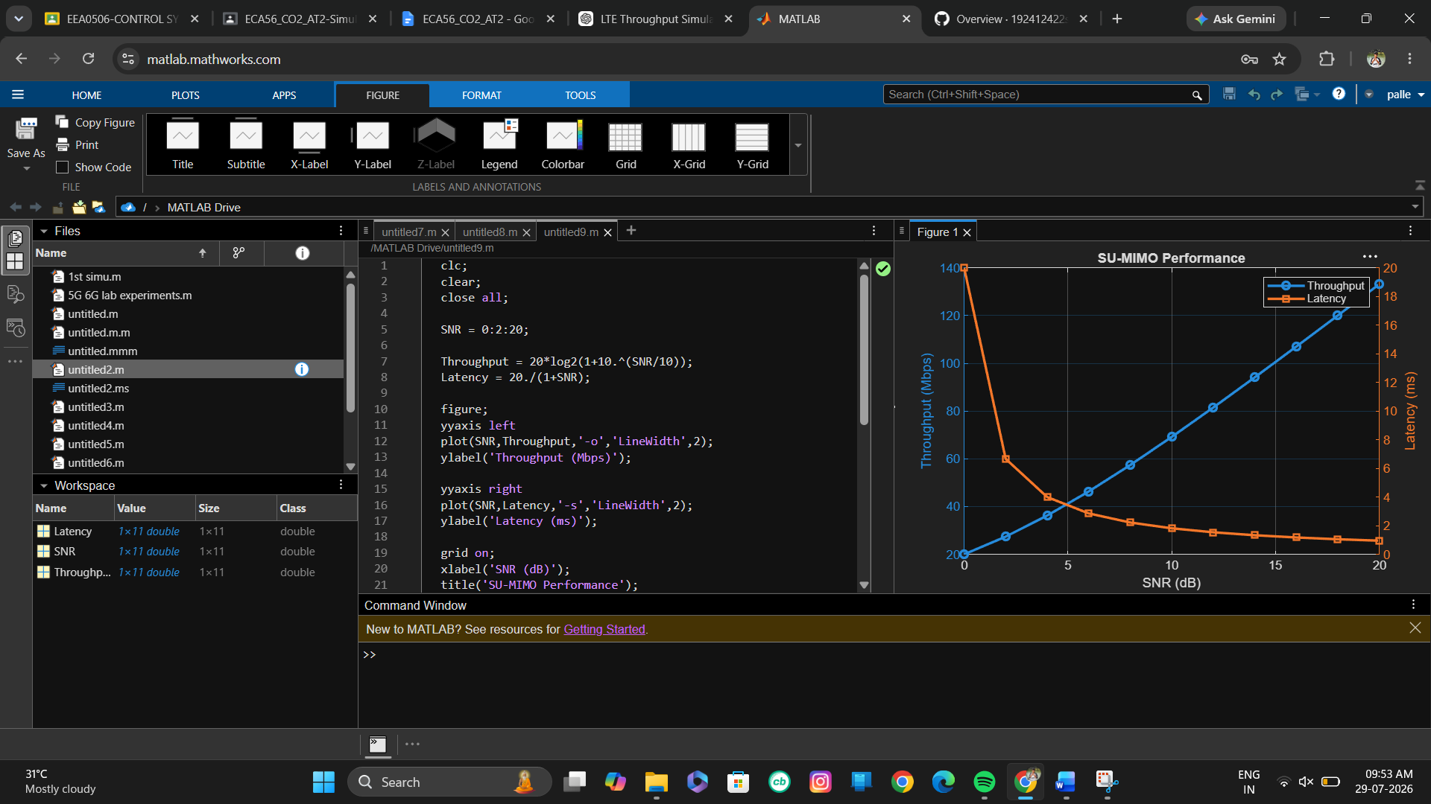
Result (2 lines):
As SNR increases, throughput increases while latency decreases. Better channel conditions improve overall SU-MIMO performance.

9. Simulation of MU-MIMO Throughput Comparison
Aim:
To simulate and compare the throughput performance of a Multi-User MIMO (MU-MIMO) system under varying user count, antenna count, SNR, modulation schemes, and interference levels using MATLAB.
Code:
clc;
clear;
close all;

Users = 1:10;
TP2 = Users*15;
TP4 = Users*22;
TP8 = Users*30;
figure;
plot(Users,TP2,'-o','LineWidth',2); hold on;
plot(Users,TP4,'-s','LineWidth',2);
plot(Users,TP8,'-^','LineWidth',2);
grid on;
xlabel('Number of Users');
ylabel('Throughput (Mbps)');
title('MU-MIMO Throughput Comparison');
legend('2 Antennas','4 Antennas','8 Antennas');
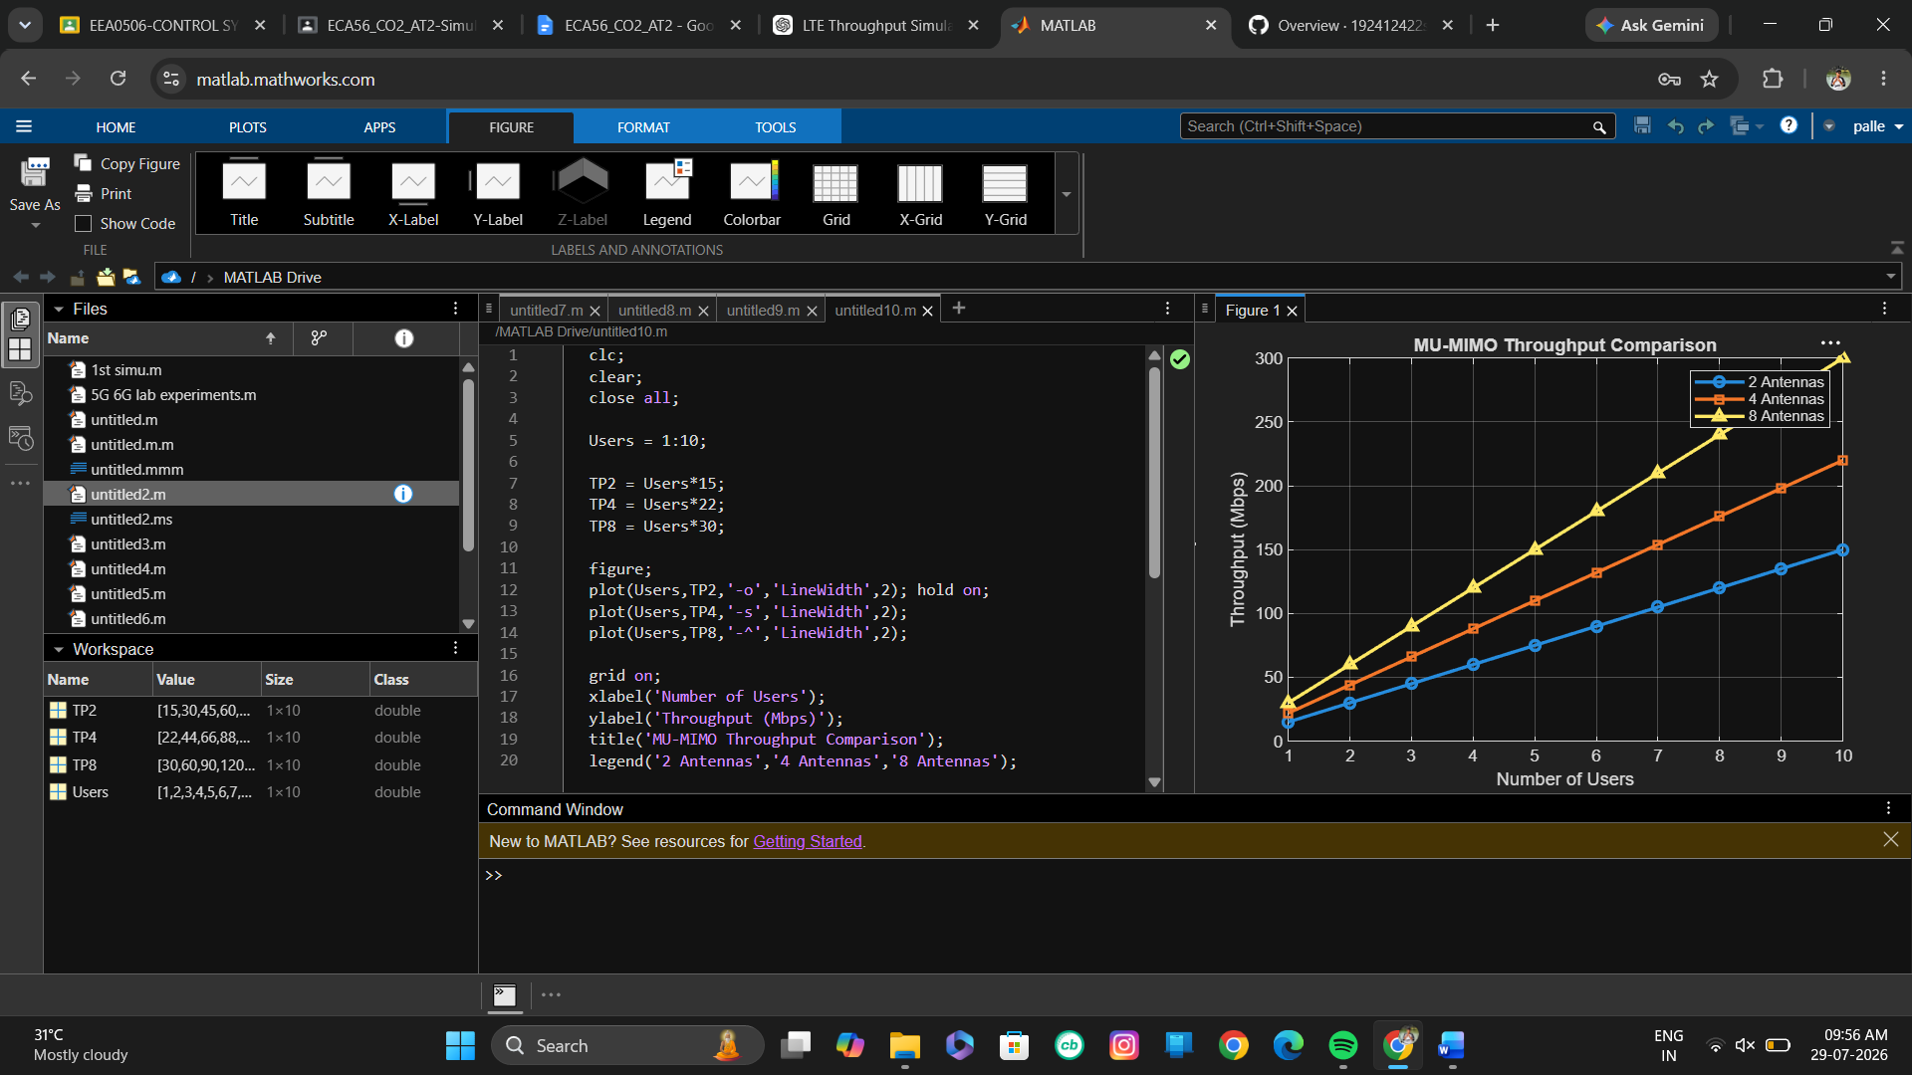

Result:
Throughput increases with the number of users and antennas. The 8-antenna MU-MIMO configuration delivers the highest system throughput.

10. Simulation of Higher-Order MIMO Diversity Gain
Aim:
To simulate and evaluate the diversity gain of higher-order MIMO systems under different fading channels, BER, outage probability, SNR, and antenna configurations using MATLAB.
Code:
clc;
clear;
close all;
SNR = 0:2:20;
D22 = exp(-0.30*SNR);
D44 = exp(-0.55*SNR);
D88 = exp(-0.80*SNR);
figure;
semilogy(SNR,D22,'-o','LineWidth',2); hold on;
semilogy(SNR,D44,'-s','LineWidth',2);
semilogy(SNR,D88,'-^','LineWidth',2);
grid on;
xlabel('SNR (dB)');
ylabel('Outage Probability');
title('Higher-Order MIMO Diversity Gain');
legend('2x2','4x4','8x8');
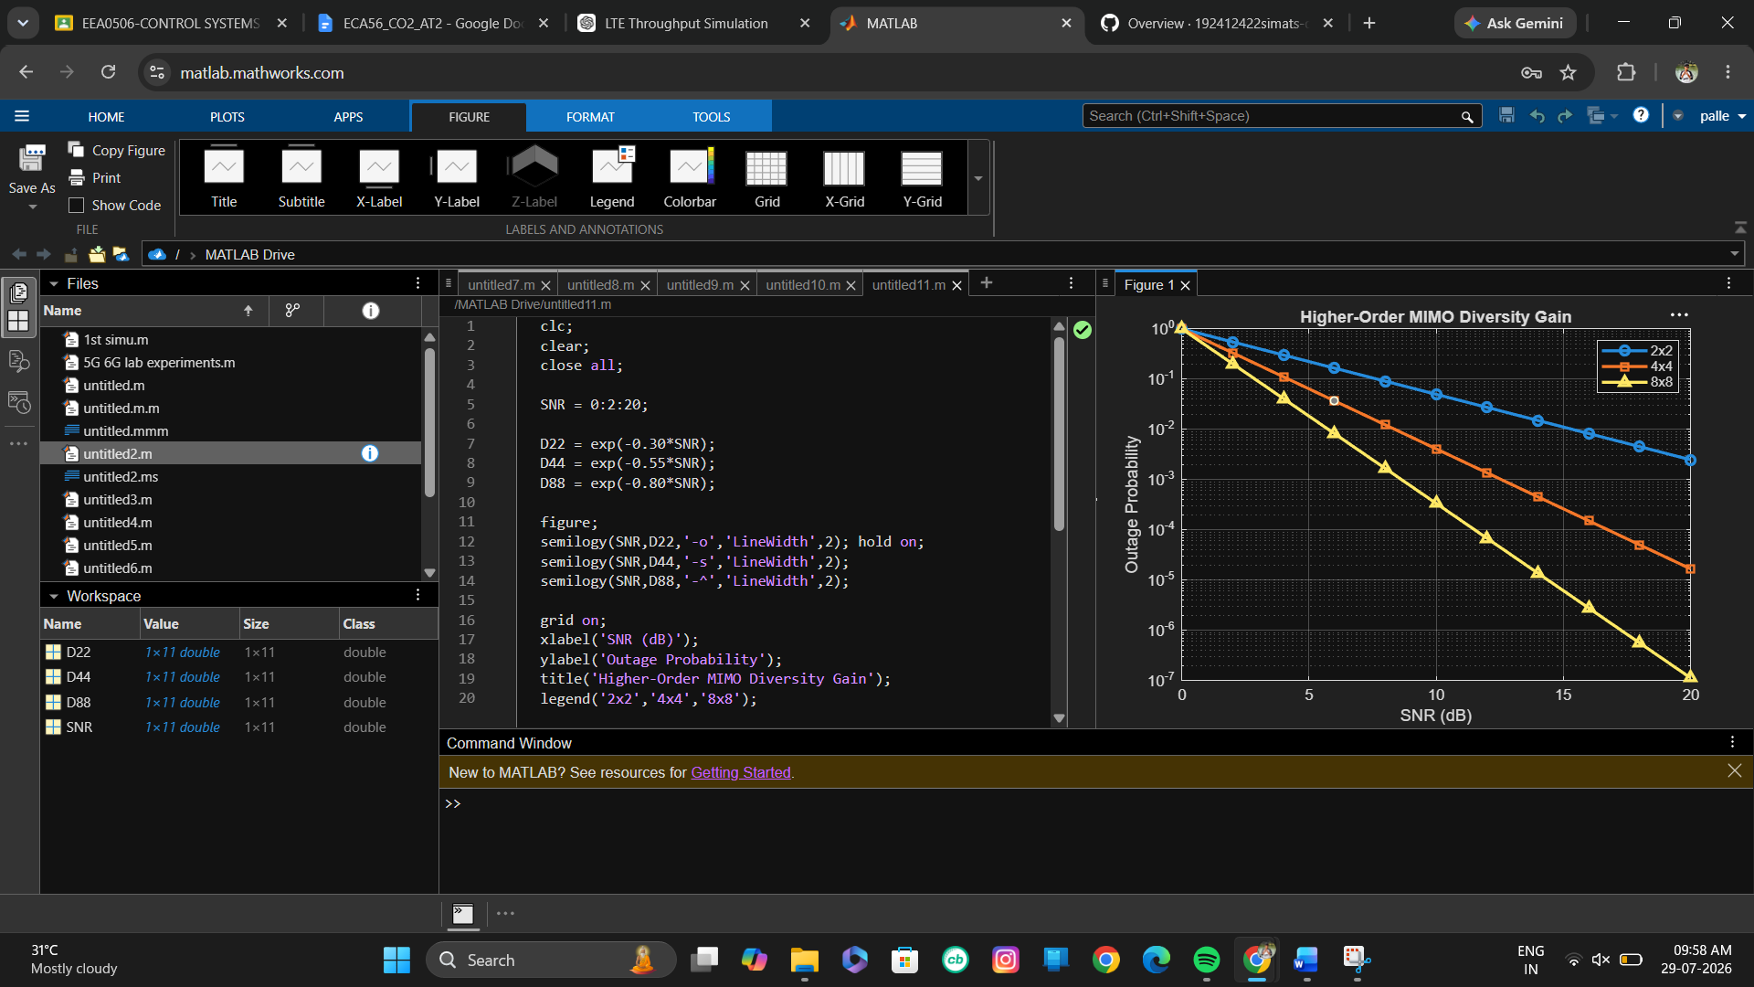
Result :
Outage probability decreases significantly as SNR and antenna diversity increase. The 8×8 MIMO system provides the highest diversity gain and the most reliable performance.

